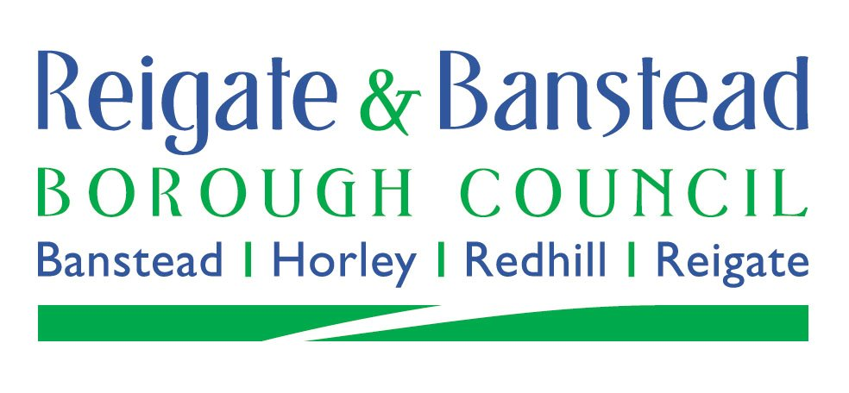

**APPLICATION FOR**

**SECTION 13A (CARE LEAVERS)**

**DISCRETIONARY RELIEF**

Date: ……………………...

Name:……………………………………………………… Date of Birth:…………………………

Address:………………………………………………………………………………………………………………………………………………………………………………………………………………

Telephone Number: …………………………………………………………………………………...

Council Tax Reference: ……………………………………………………………………………….

**I wish to apply for a Section 13A Discretionary Council Tax Relief on the grounds that I am under 25 years of age and a Care Leaver.**

1. What date did you move to this address? …………………………………………

2. List all adults (over 18) who currently occupy this address, including you.

……………………………………………………………………………………………………………………………………………………………………………………………………………………………………………………………………………….

3. If you are not the sole adult occupier, are any of the other adults care leavers under 25 years of age? **Yes/No** (delete as appropriate)

If Yes, please confirm the names and dates of birth of the other care leavers occupying the property

……………………………………………………………………………………………………………………………………………………………………………………………………………………………………………………………………………….

4. Do you consent to Reigate and Banstead Borough Council verifying you are a care leaver?

**Yes/No** (delete as appropriate)

5. If yes, please provide your personal advisers name and contact details (email address and / or telephone number).

…………………………………………………………………………………………………………………………………………………………………………………………………………………………

I declare that the information I have given on this form is correct and complete.

I know I must write and tell you of any changes in my circumstances which might affect this request (For example, if someone moves into or out of my home) within 21 days of the change.

I understand that if I do not give you correct information, or I do not tell you everything you need to know, you may take action against me.

We must protect the public funds we handle and so we may use the information you have provided on this form to prevent and detect fraud. We may also share this information, for the same purposes, with other organisations which handle public funds.

It is an offence to give false information on this form.

Signed ……………………………………………………………………………………………

Name in block capitals ………………………………………………………………………….

Please send the completed form by post to Reigate and Banstead BC, Town Hall, Castlefield Road, Reigate, Surrey, RH2 0SH, or by email to council.tax@reigate-banstead.gov.uk