Reigate & Banstead Borough Council Wins Local Authority Searches Team of the Year Award and is highly commended for two other awards at the National 2019 Local Land Charges Awards for Excellence

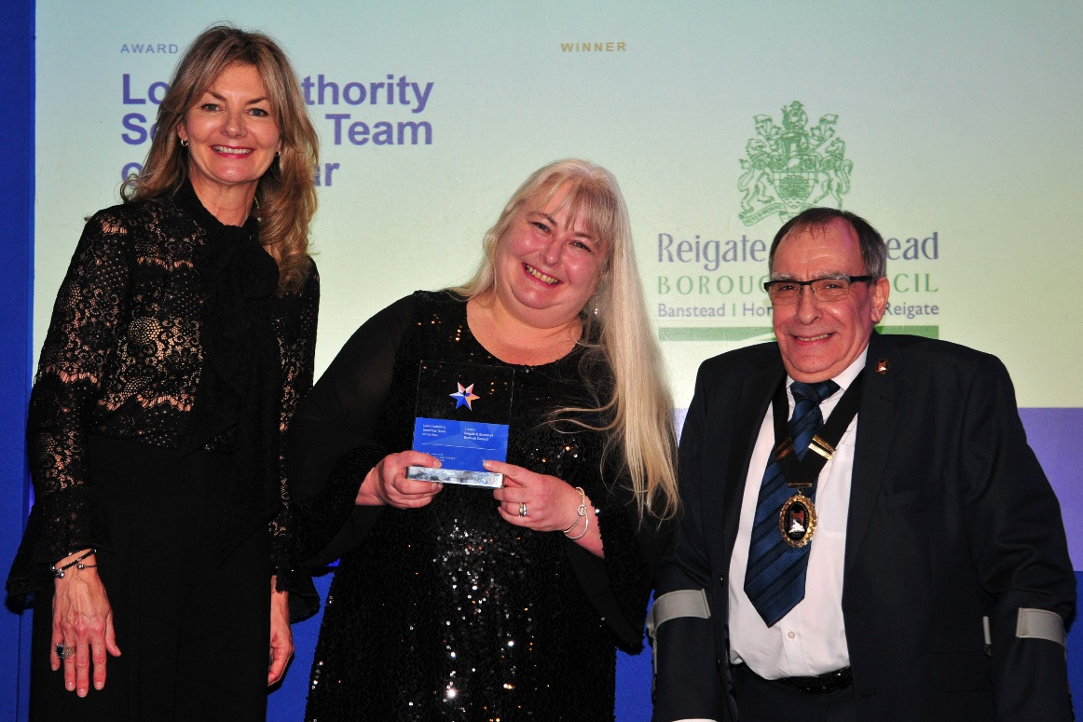

Left to right: Awards host Jo Caulfield, Maggie Judd (Reigate & Banstead BC) and Peter Audin (Local Land Charges Institute)
Reigate & Banstead Borough Council has won the Local Authority Searches Team of the Year Award at the 2019 Land Data Local Land Charges Awards for Excellence. The Awards celebrate the achievements of Local Authority Local Land Charges departments across England and Wales during the past year.
The judges for this category look for evidence of local land charges teams who can demonstrate highly effective team working, continuity of service, high levels of fully completed searches and consistently high turnaround times,
Peter Audin, President of the Local Land Charges Institute who judged this category commented: ”The entry from Reigate & Banstead was particularly impressive. We could see from their evidence there is a high level of co-operation and constructive interaction with other departments within the local authority. This plus an array of effective customer service tactics clearly demonstrates that this is a team that punches above its weight.”
Remarkably (and for the first time in the 12 year history of the Awards) the team then scooped 2 highly commended awards! One was for Customer Satisfaction for Local Authority Searches which solicitors and licensed conveyancers vote for and the second award was for the Best Customer Experience Award.
The Customer Satisfaction for Local Authority Searches category requires solicitors and licensed conveyancers around the country to nominate and provide feedback on the local authority local land charges team that they believe consistently commits to delivering a high level of customer service. Voters are asked to consider quality, efficiency, reliability and value for money. The award was presented by Andrew Simpson from the Coal Authority who sponsored the Award.

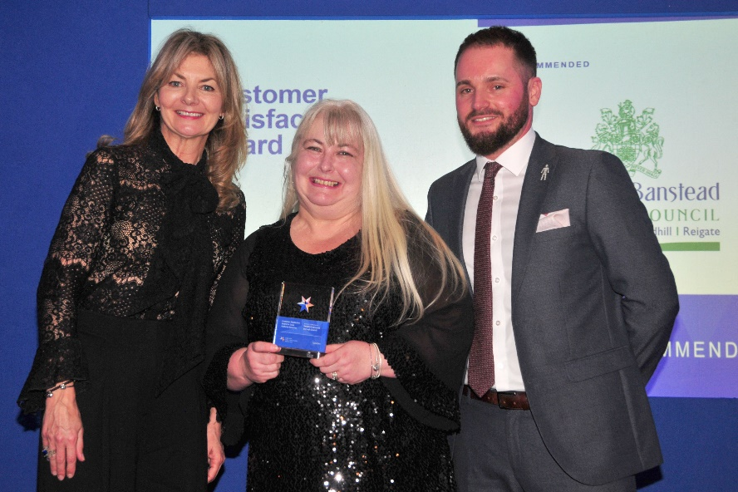

Left to right: Awards host Jo Caulfield, Maggie Judd (Reigate & Banstead BC) and Andrew Simpson (The Coal Authority)

The Best Customer Experience Award category is for the Local Land Charges department that delivers an exceptional customer experience, offering value added services in order to make the search process smoother and a solicitor’s life easier. Evidence of providing urgent searches, timeliness and customer friendly electronic copy documents are among the criteria used by judges. The award was presented by Katriona O'Hare from SearchFlow who sponsored the Award.

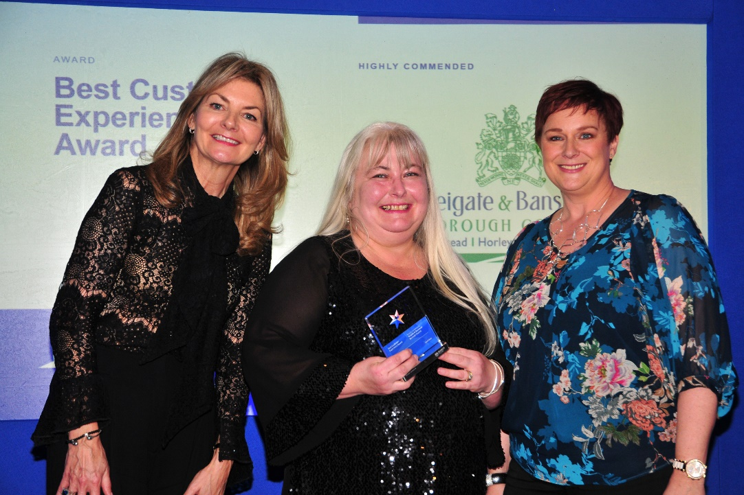

Left to right: Awards host Jo Caulfield, Maggie Judd (Reigate & Banstead BC) and Katriona O'Hare (SearchFlow)

The winners and runners-up were announced at an awards dinner hosted by comedian Jo Caulfield on 4th March 2019 in Birmingham.

For further information please contact:

Fiona Barron T: 07770 855 337 / 020 7251 8385, E: fiona.barron@land-data.org.uk, www.land-data.org.uk

#llcawards2019
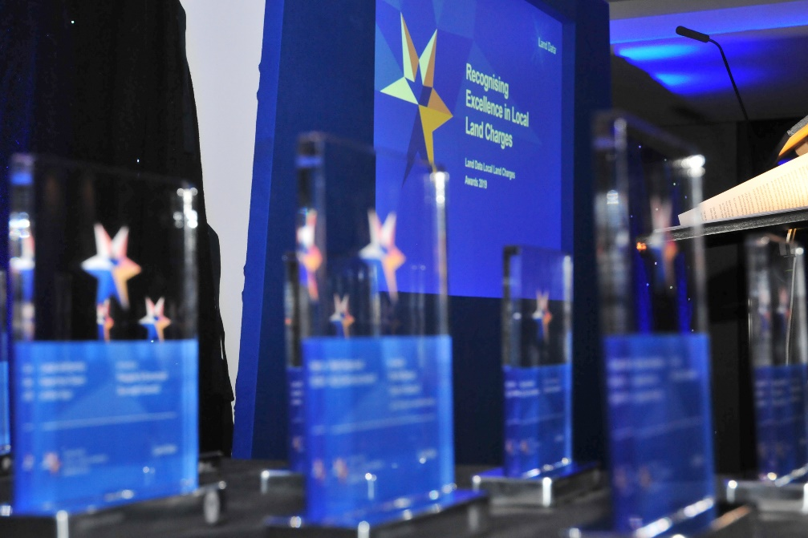
The Land Data Local Land Charges Awards for Excellence are the only national awards for the Local Land Charges Profession

